**How to run the Warranty Importer**

**Required for all imports**

1. Connect to DWH VPN
2. RDP to external facing server (WKSQL1/3)
3. RDP to application server
   1. Stop service (don’t deploy while running import)
   2. Purge error queue
4. RDP to WKCORPDEV
   1. The executables must be manually copied to the folders on E:\Lotus Importer
      1. This is only necessary if the importers have recently changed, and typically only the executable needs to be brought over
   2. Each config must be setup for each environment
      1. This should only be necessary if the configs get copied over
      2. SQL Server connection string
      3. All warranty environments pull from JDE PROD

**Lotus Base Importer**

1. Get the latest Lotus files
   1. Open up a cmd window (on WKCORPDEV)
   2. cd to E:\Lotus Importer
   3. Run: GetLotusFiles.bat
   4. Once this completes you should have updated files here:

E:\Program Files\IBM\Lotus\Notes\Data

1. Open Lotus from the desktop



1. Click on the Application icon

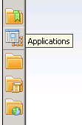

1. Click on Workspace icon

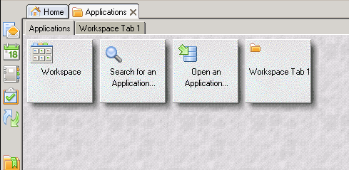

1. Double click on Export for Lotus Notes on Local icon



1. Click on each of the exports and then click the *Run Selected Exports* button and select *In Background*

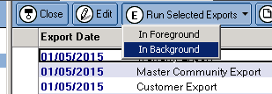

1. The following exports should be run each time a Lotus import is necessary, and can be run at the same time
   1. Warranty Export
   2. Master Community Export
   3. Customer Export
2. Wait for the exports to complete

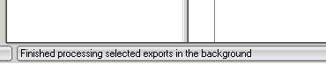

1. Copy the attachments that are exported to the appropriate share
   1. The attachments are found here:

E:\Lotus Importer\WarrantyAttachments

* 1. To speed up the process don’t replace existing files

1. cd to E:\Lotus Importer\Lotus Importer\Production
2. Run: Warranty.LotusExtract.exe
3. Select N for attachments and press enter
4. Press enter twice for the archived file paths
5. Press enter again to import all markets, or supply a comma-delimited list of the three digit market codes you would like to import (no spaces)
6. Press Y and enter after confirming your market list
7. This step may take some time and does not give status updates
8. This completes the base Lotus import
9. It is a good idea to run the *Remove Invalid Communities* step mentioned in the JDE Importer instructions

**Complete the Attachment Process**

1. After copying the files as mentioned in step 9 above
2. Open a new cmd window
3. Run: Warranty.LotusExtract.exe
4. Select Y for attachments and press enter

**Run the Archived Lotus Files**

1. Run the Lotus export for the archived files
2. Run the Lotus Importer and supply the paths to the files

**JDE Importer**

1. Open up a cmd window
2. cd to E:\Lotus Importer\Jde Importer\Production
3. Run: Warranty.JdeImport.exe –help
4. Run the imports you need